

**ONLINE SHOPPING SYSTEM**

**Software Requirement Specification**

**(Version 0.5 – 05/11/2022)**

Member:

Trần Trung Việt - HE153481

Nguyễn Trung Hiếu - HE160326

Trần Công Minh - HE161354

Lê Sỹ Thái - HE160614

Vũ Hoàng Anh - 163109

– Hanoi, November 2022 –

**Table of Contents**

I. Overview 4

1. Introduction 4

2. System Functions 5

3. Common Requirements 9

II. Functional Requirements 12

2.1. Home page 12

2.2. Register 13

2.3. Register for seller 15

2.4. Login 16

2.5. Forgot Password 18

2.6. View User Profile 19

2.7. Change Password 19

2.8. Display List Products (For user) 20

2.9. View Product Detail (For user) 21

2.10. Add to cart 22

2.11. View cart 23

2.12. Delete Product in Cart 24

2.13. CheckOut 25

2.14. Place Order 25

2.15. View order 26

2.16. View Order Detail 27

2.17. Feedback 27

2.18. View Feedback (For user) 28

2.19. Blogs List 29

2.20. Blogs Detail 30

2.21. Notification 31

2.22. Mask all as read 32

2.23. Introduciton 32

2.24. Recruitment 33

2.25. Admin Dashboard 34

2.26. List of Account (Admin) 35

2.27. Account Information (Admin) 36

2.28. Search (Admin) 37

2.29. Seller Dashboard (Seller) 38

2.30. Manager Order (Seller) 40

2.31. Manager Product (Seller) 41

2.32. Add new Product (Seller) 42

2.33. Edit Product 44

2.34. Delete product 46

2.35. Manage Feedback List (Seller) 46

2.36. Feedback Detail 47

2.37. Reply Feedback 48

# I. Overview

## 1. Introduction

This project is aimed at developing an online shop system which supports for the online shopping & product online selling for the shop or any independent organization who want to sell online. This system support for the below types of user:

• Guest: unregistered users

• Customer: they are registered users who are actual customers or potential customers

• Seller: the sale members of the organization

• Admin: the organization leader/manager, acts as the system administrator

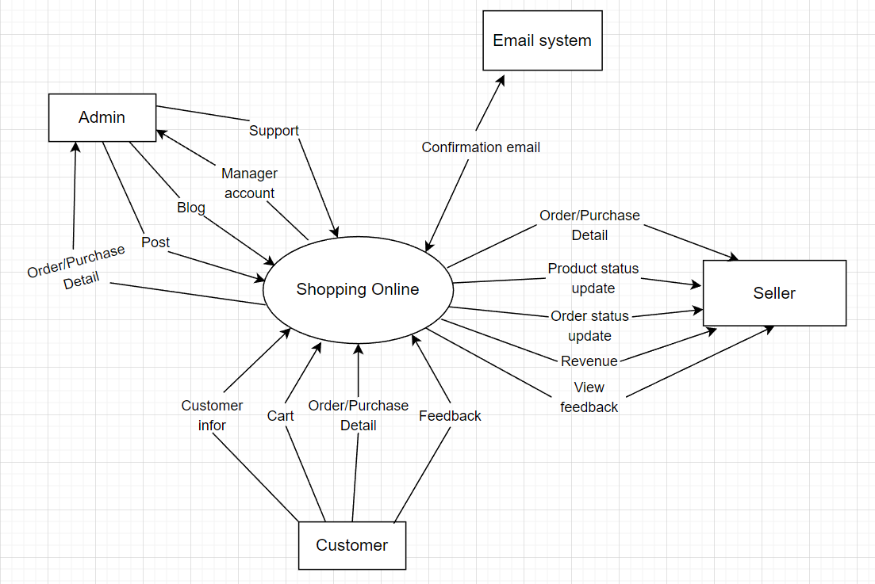

*Figure 1.1: Context Diagram For Online Shopping System*

## 2. System Functions

#### a. Screen Flow

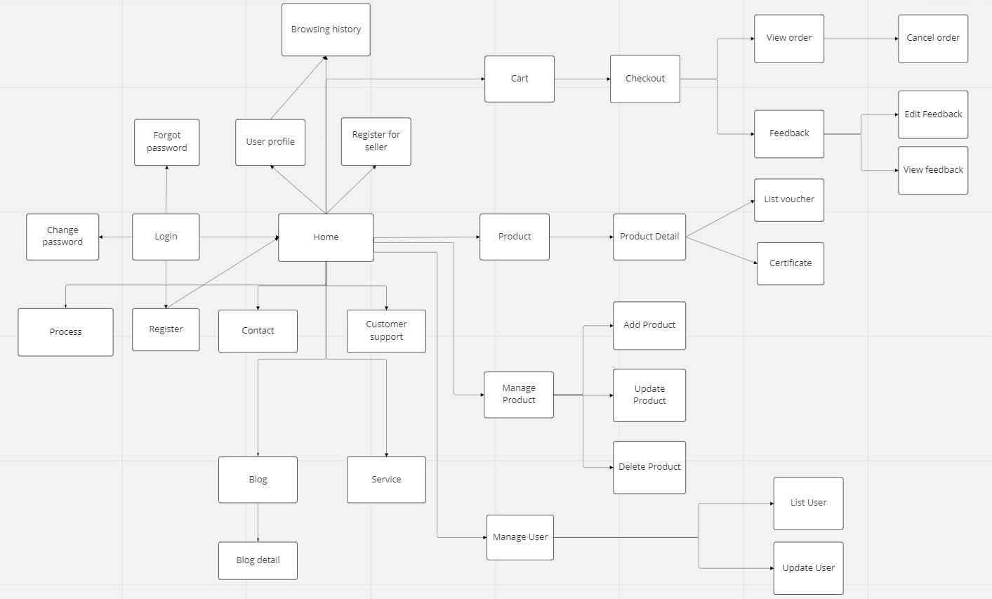

*Figure 1.2: Screen Flow For Online Shopping System*

#### b. Screen Details

|  |  |  |  |
| --- | --- | --- | --- |
| **#** | **Feature** | **Screen** | **Description** |
| 1 | Show category | Home page | User can see a list of product categories. |
| 2 | Show product | Home page | Users can see a list of the latest products, or on sale |
| 3 | Search (For user) | Home page | Allows users to search for categories, products, product types by name |
| 4 | Login | Login | Allow users to access the system |
| 5 | Register | Register | Allow users to register for a new account to access the system |
| 6 | Register for seller | Register | Allow registered users to become sellers |
| 7 | Update profile | User profile | Allow users to update personal information |
| 8 | Change password | User profile | Allow users to change their personal password |
| 9 | Add address | User profile | Allow users to add an address to receive goods |
| 10 | Reset password | Reset password | The user requests to get new password |
| 11 | Add to cart | Product detail | The user will add the product to be purchased to the cart |
| 12 | View cart | Cart | User can see all the products that have been added in the cart |
| 13 | View order | My order (Customer) | User can see all their created orders |
| **#** | **Feature** | **Screen** | **Description** |  |  | **Screen** | **Description** |
| 14 | Cancel order | My order (Customer) | Users can cancel orders that don't want to buy |
| 15 | View favorite products | My Wishlist  (Customer) | Users can view products that have been added to favorites |
| 16 | View detailed statistics | Admin dashboard | Allows administrators to view detailed statistics, revenue, transaction history, .. |
| 17 | View list of accounts | Account Management (Admin) | Admin can view all user information in the system, or disable the account. |
| 18 | Search (For admin) | Account Management (Admin) | Admin can search for account by name, role |
| 19 | View list of shops | Shop Management (Admin) | Admin can see the information of the store, store owner, total products posted for sale |
| 20 | Search shop | Shop Management (Admin) | Quickly search for a store by store name, or store owner's name |
| 21 | View report | Report From Users (Admin) | View a list of reports submitted by users to the system through the Report function |
| 22 | Search Report | Report From Users (Admin) | Allows administrators to quickly search for a person's report when too many reports are sent to the system |
| 23 | View detailed statistics | Seller dashboard | Allows seller to view post statistics, products, customers, revenue, feedback & new customer trends |
| 24 | Add product | Manage Products (Seller) | Seller can add new products to the shop's product list |
| 25 | Edit product | Manage Products (Seller) | Seller can change the information of the product |
| 26 | Delete product | Manage Products (Seller) | Seller can delete product when the shop no longer sell it |
| 27 | Update order status | Manage Orders (Seller) | Seller can update the status of orders (wait for confirmation, delivery, delivered, canceled) |
| 28 | Delete order | Manage Orders (Seller) | Seller can delete order when order is canceled |
| 29 | Add new Blog | Manage Blogs (Seller) | Sellers can post new Blog posts on the website |
| 30 | Edit blog | Manage Blogs (Seller) | Sellers can edit the content, images, titles of old Blog posts |
| 31 | Delete Blog | Manage Blogs (Seller) | Remove Blog post from list |
| 32 | View list Feedback | Manage Feedback (Seller) | Sellers can see a list of user reviews about their products |
| 33 | Reply Feedback | Manager Feedback (Seller) | Sellers can respond to user reviews about their products |
| 34 | Add Feedback | Add Feedback (Customer) | Submit a product feedback review after a successful purchase |
| 35 | Report Shop | Report Shop (Customer) | Users can report back to the Administrator about the stores if they encounter a case of a store selling banned products, obscene, ... |
| 36 | Chat with Seller | Chat With Seller (Customer) | Allow users to message directly with sellers |
| 37 | View list blog | Blog (Customer) | Show the posts pagination the post search box, post categories, five featured posts |
| 38 | View blog detail | Blog detail (Customer) | Show post details, post categories, five featured posts. The Blogs List page is shown when the user clicks on a post category |
| 39 | Comment on Blog posts | Comment Blogs (Customer) | Write a review on a Blog post on the page after viewing it |
| 40 | Search Blog | Blog (Customer) | So that users can quickly search Blogs posts |
| 41 | View Service | Service (Customer) | If users need support or guidance, they can go to the Service section to see |
| 42 | Search Service | Service (Customer) | Find quick help with keywords |
| 43 | View Products History | Products History (Customer) | So that users can know their own purchase and viewing history |

#### c. User Authorization

|  |  |  |  |  |
| --- | --- | --- | --- | --- |
| **Screen** | **Role1** | **Role2** | **Role3** | **Role4** |
| Home page | X | X | X | X |
| Register | X | X | X |  |
| Register for seller |  | X | X |  |
| Login |  | X | X | X |
| Forgot password |  | X | X |  |
| Use profile |  | X | X | X |
| Add addresses |  | X |  |  |
| Change password |  | X | X |  |
| Admin dashboard |  |  |  | X |
| Seller dashboard |  |  | X |  |
| List of account |  |  |  | X |
| Account information |  |  | X | X |
| Product list |  |  | X | X |
| Category list |  |  | X | X |
| Add product |  |  | X |  |
| Edit product |  |  | X |  |
| Add category |  |  | X |  |
| Edit category |  |  | X |  |
| Search | X | X | X | X |
| Product status update |  |  | X |  |
| Update order status |  |  | X |  |
| View product detail | X | X | X | X |
| View shopping cart |  | X | X | X |
| Check out |  | X | X | X |
| View order |  | X | X | X |
| Cancel order |  | X | X | X |
| Feedback |  | X |  |  |
| View feedback | X | X | X | X |
| Feedback detail | X | X | X | X |
| Check bill |  | X | X |  |
| Supporting |  |  | X | X |
| List vouchers | X | X |  |  |
| Blogs list | X |  | X | X |
| Blogs detail | X | X | X | X |
| Service Support | X | X | X | X |
| List Service | X | X | X | X |
| Contact | X | X | X | X |
| Certificate | X | X | X | X |
| Service | X | X | X |  |
| Report page |  | X |  |  |
| Browsing history |  | X |  |  |
| Delivery method |  | X |  |  |
| Chat |  | X | X | X |

In which:

* Role1: Guest
* Role2: Customer
* Role3: Seller
* Role4: Admin

#### d. Non-Screen Functions

|  |  |  |  |
| --- | --- | --- | --- |
| **#** | **Feature** | **System Function** | **Description** |
| 1 | Remember Me | Login | System store user’s login account and password in cookies for future re-login |
| 2 | … |  |  |

## 3. Use-Case Diagram

#### a. General Use-Case Diagram

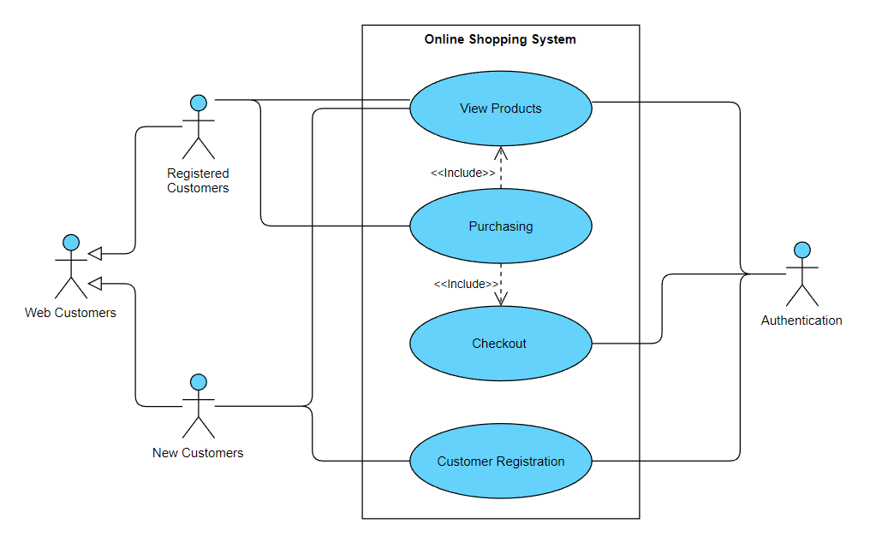

*Figure 3a Use-Case Diagram for Online Shopping System*

#### b. Admin’s Management System

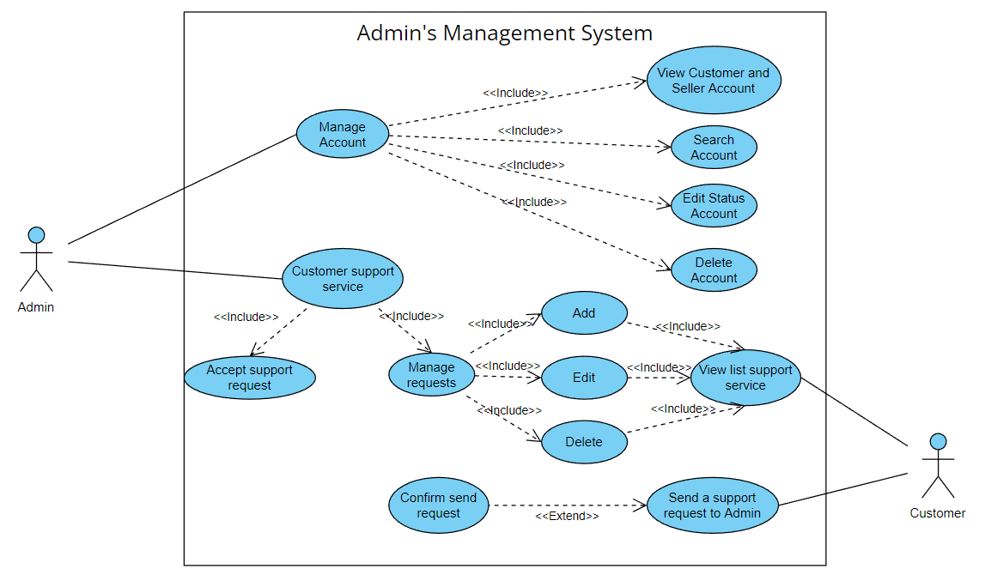

*Figure 3b Use-Case Diagram for Admin’s Management System*

#### c. Seller’s Management System

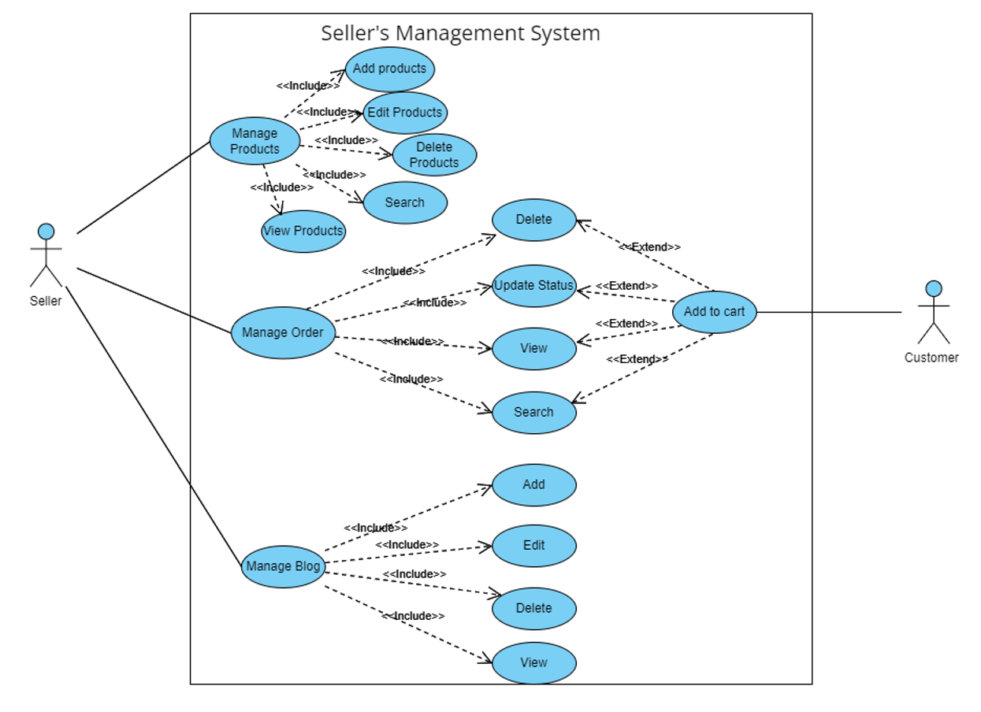

*Figure 3c Use-Case Diagram for Seller’s Management System*

#### d. Shopping Cart Use-Case Diagram

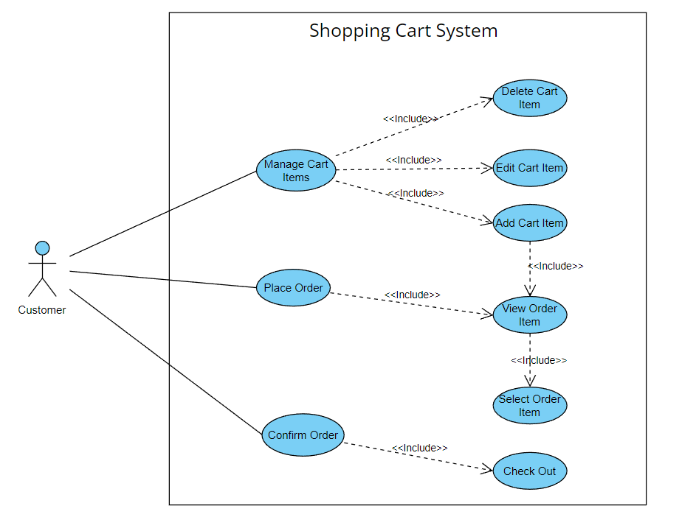

*Figure 3d Use-Case Diagram for Shopping Cart System*

# II. Functional Requirements

### 2.1. Home page

* Function trigger: The user visits the website's address then goes to the home page.
* Function description:
  + Actors/Roles: Guest, Customer
  + Purpose: Showcase feature product to customer
* Screen layout:

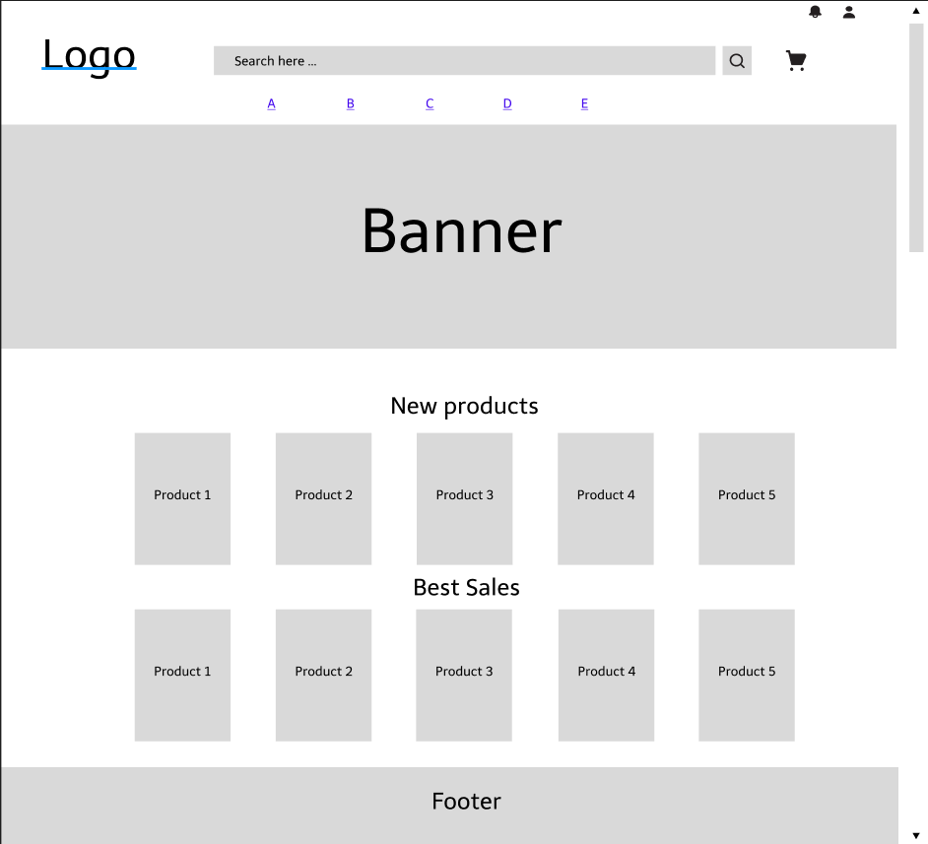

*Figure 2.1 Homepage screen*

* Function Details: Customers after accessing the website by following the link can view product information, categories, banners, latest products, discounts, brands, search for products, ...

### 2.2. Register

* Function trigger: After the user hovers over the person icon on the home page and chooses to register, the system will take the user to the Register page.
* Function description:
  + Actors/Roles: Guest
  + Purpose: Provide a form for customer to register an account.
  + Interface: There are pictures to welcome customers.
  + Data processing: Save email, username, password to data management system.
* Screen layout:

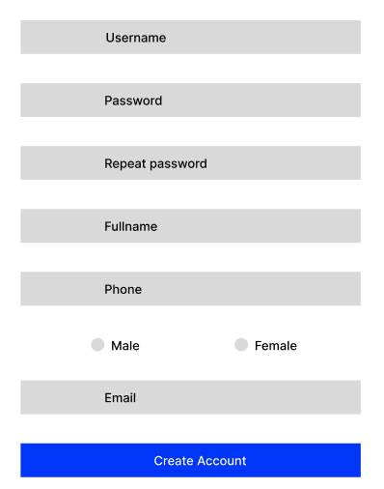

*Figure 2.2 Register screen*

* Function Details: Users register a new account by email, set a password for their account then click the Register button.
* Use-Case Description:

|  |  |
| --- | --- |
| Use Case ID | UC-01 |
| Use Case Name | Register |
| Actor | User |
| Description | This use case allows the user to register a new account which is used to access the system |
| Precondition | Do not have an account to log in to the system |
| Post-Condition | None |
| Main Flow | 1. User enters username, password and personal information  2. User submits username, password and personal information to the system  3. System to check the existence of Username  4. The system will check if the password entered in 'Confirm Password' is the same  5. System to check password format, phone number, email  6. Redirect to login page  7. End of use case |
| Alternative flows | 3a. Username exists  1. Error message username exists  2. The use case resumes at main flow step 1  4a. Password not same  1. Error message password is not the same  2. The use case resumes at main flow step 1  5a. Malformed  1. Show input request in correct format  2. The use case resumes at main flow step 1 |

### 2.3. Register for seller

* Function trigger: When the user clicks the button Become a seller, the system will go to the page Register to become a seller.
* Function description:
  + Actors/roles: Customer
  + Purpose: For users who want to become product sellers.
  + Data processing: Update account status from Customer to Seller.
* Screen layout:

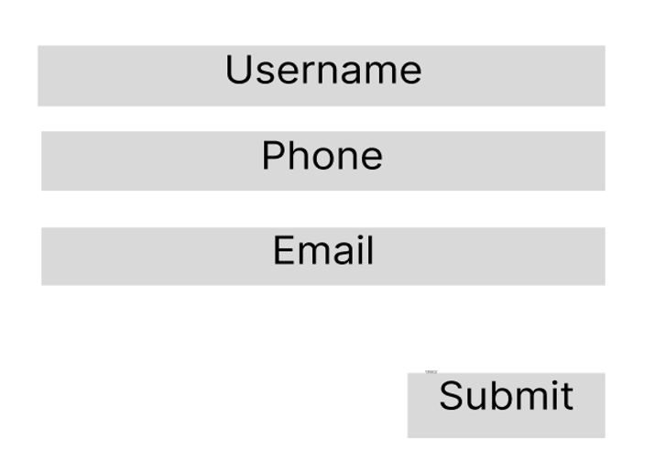

*Figure 2.3 Register For Seller Screen*

* Function Details: Register information to become a seller.
* Use-Case Description:

|  |  |
| --- | --- |
| Use Case ID | UC-02 |
| Use Case Name | Register for seller |
| Actor | User |
| Description | This use case allows users to sign up to become a seller |
| Precondition | Already have a valid account |
| Post-Condition | None |
| Main Flow |  |
| Alternative flows |  |

### 2.4. Login

* Function trigger: After the user hovers over the person icon on the home page and chooses to login, the system will take the user to the Login page.
* Function description:
  + Actors/Roles: Guest, Customer
  + Purpose: Allow users to login to the system to access more functions
  + Interface: There are header, wallpapers, website logos
  + Data processing: Check if the user has entered the wrong username or password, if wrong will display a message asking to re-enter. If entered correctly redirect the user to the Homepage.
* Screen layout:

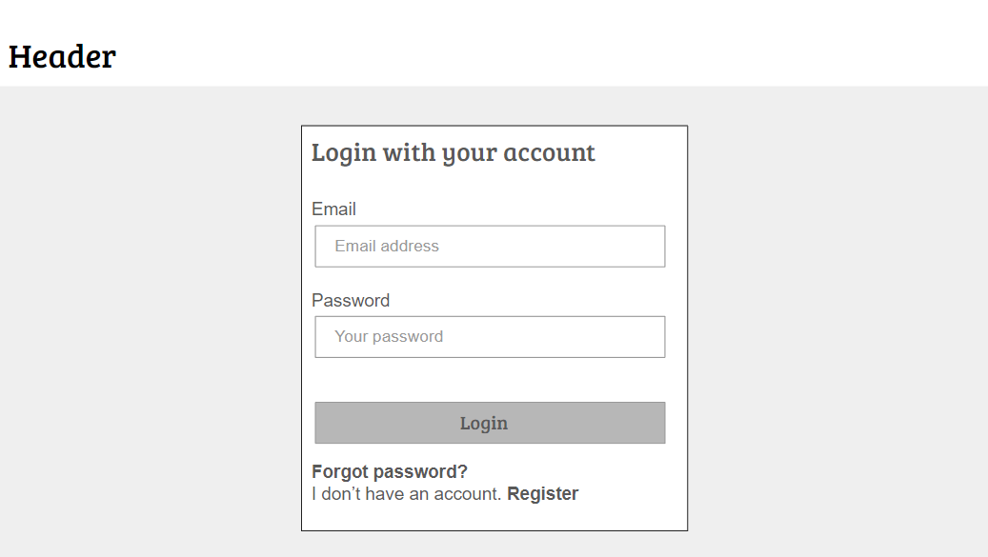

*Figure 2.4 Login screen*

* Function Details: User enters their email/username and password, then clicks the Login button to enter the homepage of the Website.
* Use-Case Description:

|  |  |
| --- | --- |
| Use Case ID | UC-03 |
| Use Case Name | Login |
| Actor | User, Admin |
| Description | This use case allows the user to register a new account which is used to access the system |
| Precondition | User has to have a valid account |
| Post-Condition | The system displays the relevent account |
| Main Flow | 1. User enters username, password  2. User submits username, password  3. The system vertifies username and password  4. Redirect users to the homepage  5. End of use case |
| Alternative flows | 3a. Username or password does not exist  1. Display "Invalid Username or Password" message  2. The use case resumes at main flow step 1 |

### 2.5. Forgot Password

* Function trigger: When user clicks to forgot password in Login screen.
* Function description:
  + Actors/Roles: Customer, Seller, Admin
  + Purpose: Users can change their passwords when they forget their old one
  + Data processing: Check the email of the user entered to see if it matches the registered email, if it is, the new password will be sent to the customer's email, if not, it will be required to re-enter.
* Screen layout:

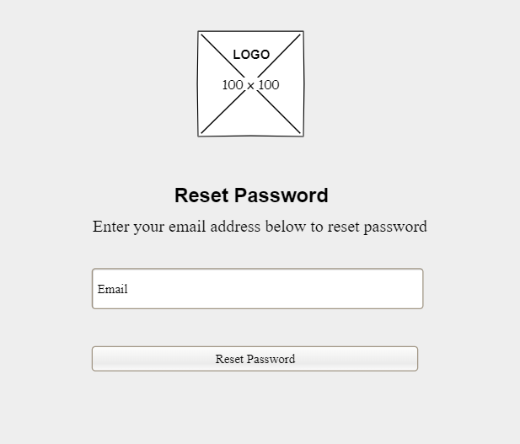

*Figure 2.5 Reset Password screen*

* Function Details: Users enter the email they used to register for an account, then the system will send a new password to the email and delete the old password.
* Use-Case Description:

|  |  |
| --- | --- |
| Use Case ID | UC-04 |
| Use Case Name | Forgot password |
| Actor | User |
| Description | This use case allows the user to retrieve the password when it is forgotten |
| Precondition | Have a valid registered email |
| Post-Condition | None |
| Main Flow | 1. Users enter their personal email used to register an account  2. Click the Reset Password button  3. The system will verify the email  4. The use case ends |
| Alternative flows | 3a. The email entered does not exist or is incorrect  1. Show "Incorrect email" message  2. The use case resumes at main flow step 1  3b. Accurate email confirmation system  1. Display the message "The system has sent a password to your email. Please check your email"  2. The use case ends |

### 2.6. View User Profile

* Function trigger: The user logs into the site, after that hovers over the person icon in the upper right corner and selects View profile.
* Function description:
  + Actors/Roles: Customer, Seller, Admin .
  + Purpose: Users can see their account’s detailed information.
  + Interface: There's a profile picture on the left side of the screen, details information in the middle, and About us on the right.
* Screen layout:

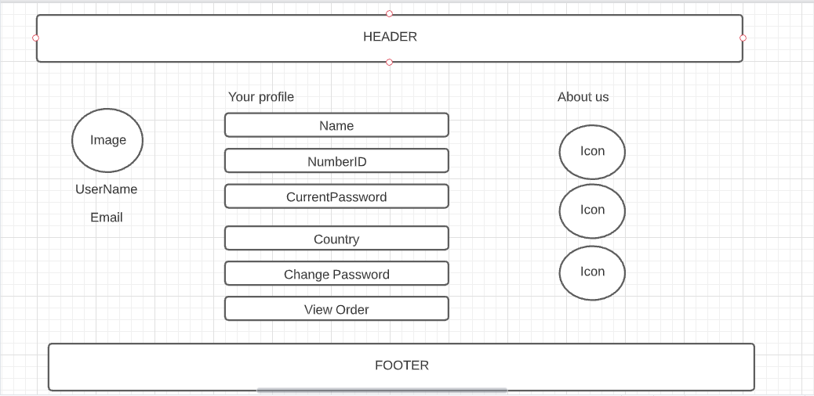

*Figure 2.6 User Profile screen*

* Function Details: Users can view their personal information.
* Use-Case Description:

|  |  |
| --- | --- |
| Use Case ID | UC-05 |
| Use Case Name | User Profile |
| Actor | User |
| Description | This use case allows the user to view a detailed profile page |
| Precondition | Have a valid login account |
| Post-Condition | None |
| Main Flow |  |
| Alternative flows |  |

### 2.7. Change Password

* Function trigger: When the user wants to change the account password.
* Function description:
  + Actors/roles: Customer, Seller, Admin
  + Purpose: User can change password.
  + Interface: Display form including: Current Password, New Password, Confirm New Password.
  + Data processing: Update client's current password.
* Screen layout:

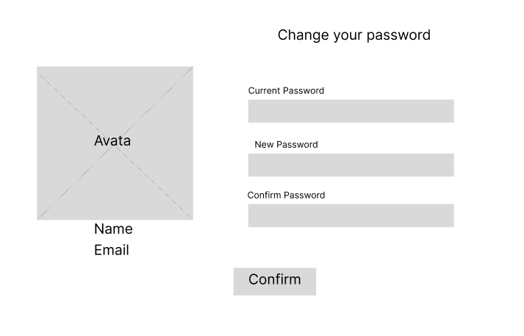

*Figure 2.7 Change Passowrd screen*

* Function Details: provide explanation for the data, validation, business logics, functionalities (for both normal cases and abnormal cases), etc. of the function so that the reader can image how it work
* Use-Case Diagram:
* Use-Case Description:

|  |  |
| --- | --- |
| Use Case ID | UC-06 |
| Use Case Name | Change password |
| Actor | User |
| Description | This use case allows user to change login password |
| Precondition | Have a valid login account |
| Post-Condition | None |
| Main Flow |  |
| Alternative flows |  |

### 2.8. Show Products (For user)

* Function trigger: Users visit the website then click on the product category name on the Home page or search for the product by name.
* Function description:
  + Actors/roles: Guest, Customer
  + Purpose: Allows users to filter product information, sort, view all available products, latest products, best sellers.
  + Interface: There is a search filter on the left side of the screen, the product list in the middle of the screen.
  + Data processing: The system will search according to the information provided by the user (retrieved from the search filter, product name, category).
* Screen layout:

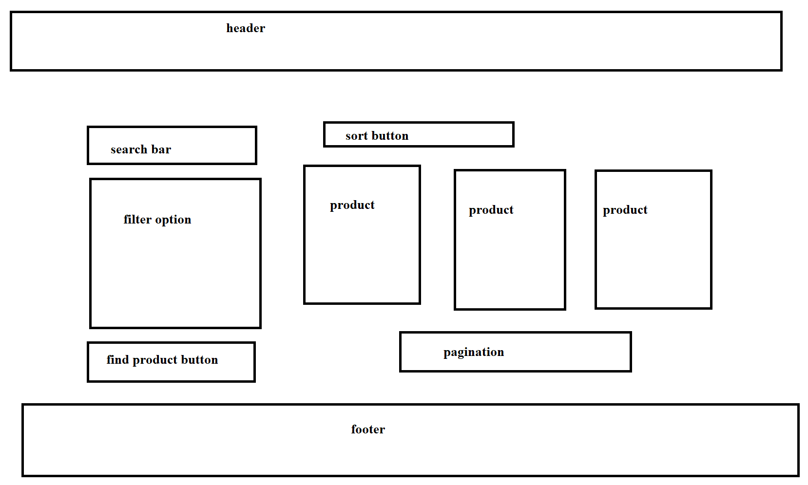

*Figure 2.8 Change Passowrd screen*

* Function Details: Display a detailed list of products for users to see.
* Use-Case Description:

|  |  |
| --- | --- |
| Use Case ID | UC-07 |
| Use Case Name | View Products |
| Actor | User |
| Description | This use case allows the user to see a list of products displayed on the online store |
| Precondition | None |
| Post-Condition | None |
| Main Flow | 1. Successfully accessed the online store using the link  2. Click on the Product link on navbar  3. The use case ends |
| Alternative flows | None |

### 2.9. View Product Detail (For user)

* Function trigger: User click on a Product in Product List.
* Function description:
  + Actors/roles: Guest, Customer.
  + Purpose: User can view all the detail information of a Product.
  + Interface: Title bar, product image on the left side of the screen, on the right side of the screen is the product name, price, quantity selection, 2 Add to Cart and Buy now buttons. Product description below.
  + Data processing: Get the number and size of products that the user chooses to save to the cart.
* Screen layout:

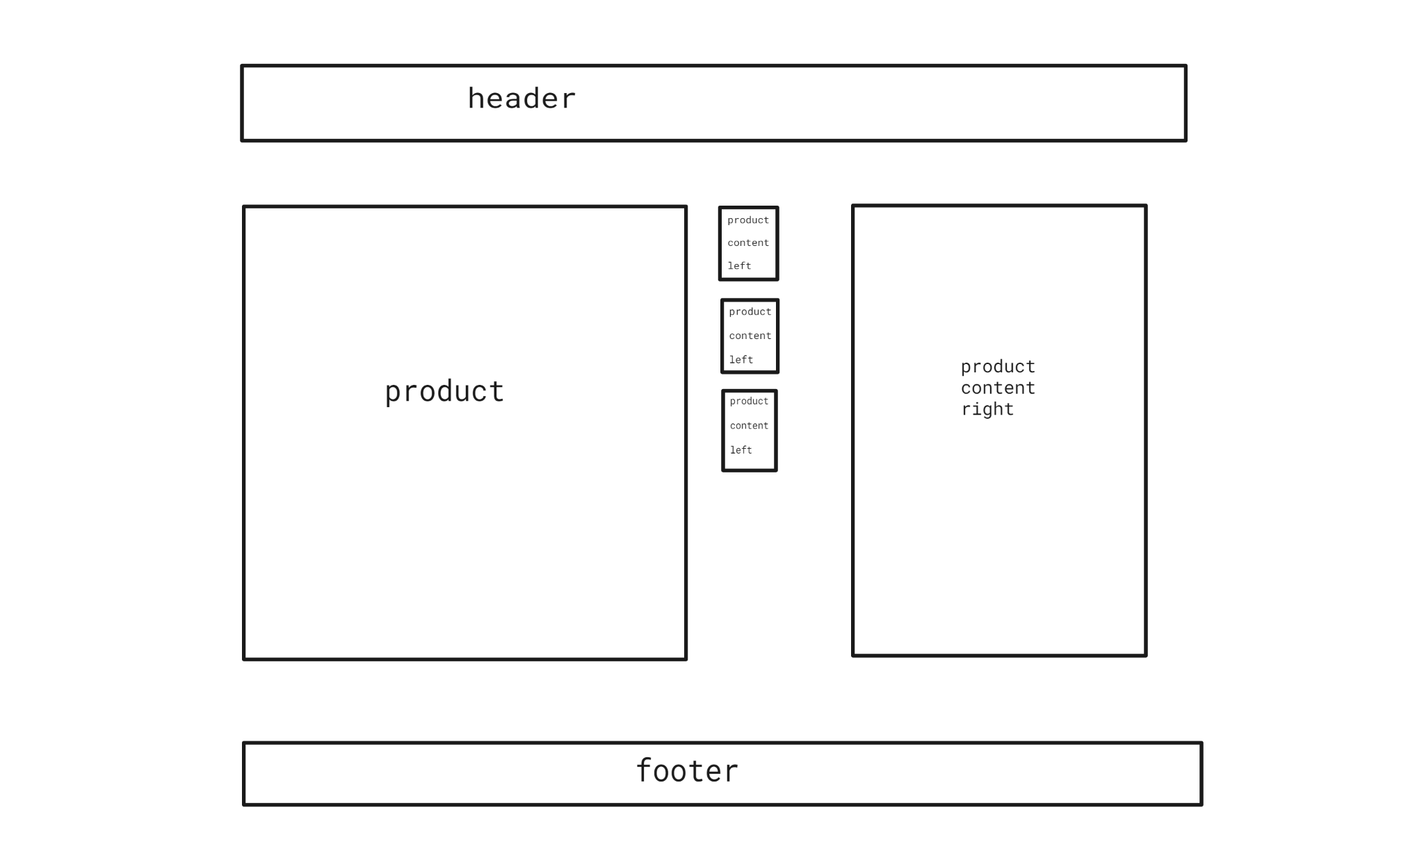

*Figure 2.9 Product Detail screen*

* Function Details: Display detailed information of the product to the user.
* Use-Case Description:

|  |  |
| --- | --- |
| Use Case ID | UC-08 |
| Use Case Name | Product Detail |
| Actor | User |
| Description | This use case allows the user to view detailed information of a product such as price, color, size, product description, etc. |
| Precondition | None |
| Post-Condition | None |
| Main Flow | 1. Successfully accessed the online store using the link  2. Click on the product name and photo to view detailed information  3. The use case ends |
| Alternative flows | None |

### 2.10. Add Address

* Function trigger: The user clicks on the Add new address button.
* Function description:
  + Actors/roles: Guest, Customer.
  + Purpose: Let the user to add personal addresses.
  + Interface: Have a button Add new Address.
  + Data processing: The data will be saved in the Address table in the Database.
* Screen layout:

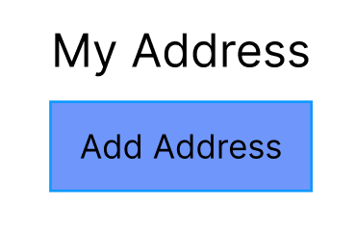

*Figure 2.10.1 Add Address button*

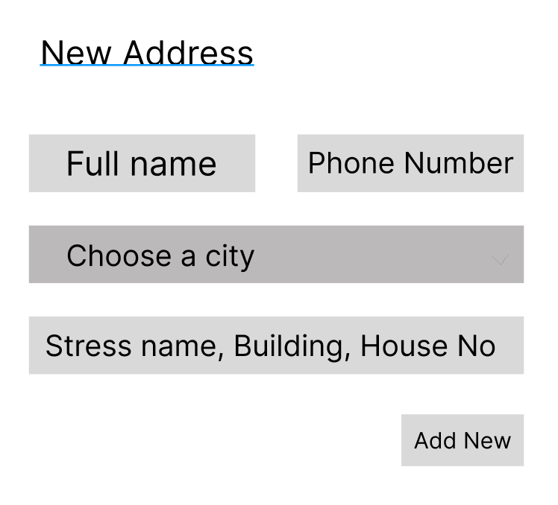

*Figure 2.10.2 Add Address modal (After clicking the button)*

* Function Details: Add a new user's personal address.
* Use-Case Description:

|  |  |
| --- | --- |
| Use Case ID | UC-09 |
| Use Case Name | Add Address |
| Actor | User |
| Description | This use case allows the user to add new user’s personal address |
| Precondition | None |
| Post-Condition | None |
| Main Flow | 1. Go to profile page  2. Click on the Address button  3. The screen displays as shown in Figure 2.10.1. Then click on the Add Address button  4. The display screen as shown in Figure 2.10.2  5. The use case ends |
| Alternative flows | None |

### 2.11. Edit Address

* Function trigger: The user clicks on the Edit button.
* Function description:
  + Actors/roles: Guest, Customer.
  + Purpose: Let the user to edit personal addresses.
  + Interface: Have a button Edit.
  + Data processing: The system will take the data saved in the Database and display it on the box. Then the user enters new information and Clicks on the Update button, the new data will be updated into the Database.
* Screen layout:

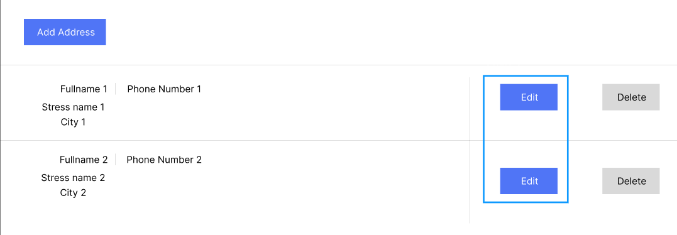

*Figure 2.11.1 Edit Address button (Green border)*

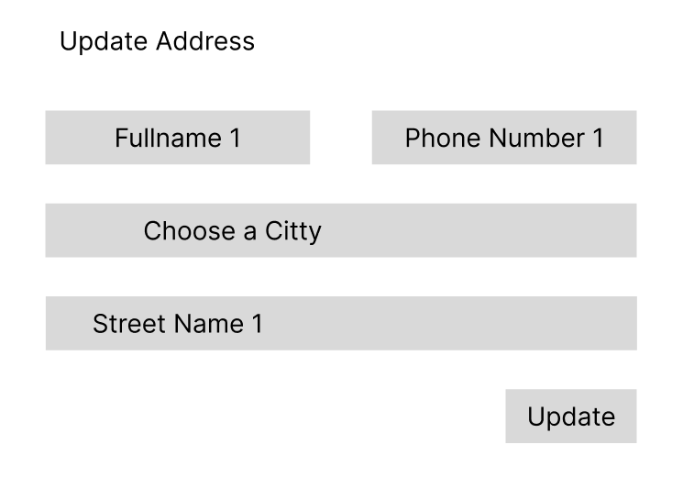

*Figure 2.11.2 Update Address modal (After clicking the Edit button)*

* Function Details: Add a new user's personal address.
* Use-Case Description:

|  |  |
| --- | --- |
| Use Case ID | UC-10 |
| Use Case Name | Edit Address |
| Actor | User |
| Description | This use case allows the user to re-edit his personal address |
| Precondition | None |
| Post-Condition | None |
| Main Flow | 1. Go to profile page  2. Click on the Address button  3. The screen displays as shown in Figure 2.11.1. Then click on the Edit Address button  4. The display screen as shown in Figure 2.11.2  5. The use case ends |
| Alternative flows | None |

### 2.12. Delete Address

* Function trigger: The user clicks on the Delete button.
* Function description:
  + Actors/roles: Guest, Customer.
  + Purpose: Allow users to delete addresses from the list.
  + Interface: Have a button Delete.
  + Data processing: The data will be deleted from the User Address table in the Database.
* Screen layout:

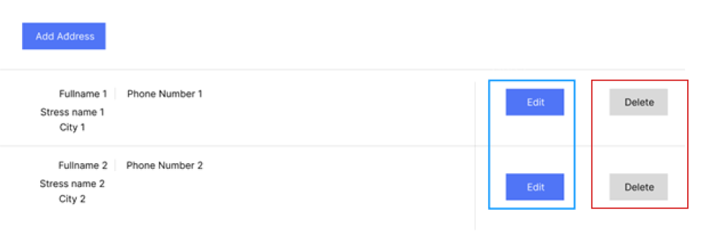

*Figure 2.12 Delete Address button (Red border)*

* Function Details: Add a new user's personal address.
* Use-Case Description:

|  |  |
| --- | --- |
| Use Case ID | UC-11 |
| Use Case Name | Delete Address |
| Actor | User |
| Description | This use case allows the user to delete his/her personal address |
| Precondition | None |
| Post-Condition | None |
| Main Flow | 1. Go to profile page  2. Click on the Address button  3. The screen displays as shown in Figure 2.12.1. Then click on the Delete Address button  4. The screen displays a message asking "Are you sure you want to delete this address?"  5. If "No" is selected, return to Main Flow 3, if "Yes" is selected, the address will be deleted  6. The use case ends |
| Alternative flows | None |

### 2.13. Update Profile

* Function trigger: Users who want to update their personal information.
* Function description:
  + Actors/roles: Guest, Customer.
  + Purpose: For users to update personal information such as full name, phone number, email, ...
  + Interface: There are 3 comboboxes that store full name, phone number, email and 2 radio for male and female gender, 1 button Save Profile.
  + Data processing: The data is stored in the Users table in the Database.
* Screen layout:

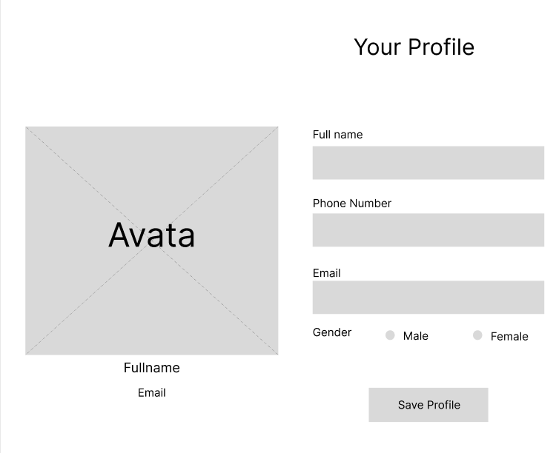

*Figure 2.13 Update Profile*

* Function Details: Update personal information.
* Use-Case Description:

|  |  |
| --- | --- |
| Use Case ID | UC-12 |
| Use Case Name | Update Profile |
| Actor | User |
| Description | This use case allows the user to update personal information |
| Precondition | None |
| Post-Condition | None |
| Main Flow | 1. Click on the link to go to User Profile  2. Display the screen as shown in Figure 2.11  3. Enter information fields in the boxes  4. Click the Save Profile button  5. The use case ends |
| Alternative flows | 3a. Enter the wrong phone number format  1. Show "Phone Format error" error message  2. Go back to Main flow step 3  3b. Enter the wrong email format  1. Show "Email Format error" error message  2. Go back to Main flow step 3 |

### 2.14. View cart

* Function trigger: When the user clicks on the Cart icon, the system will take the user to the Cart shopping detail page.
* Function description:
  + Actors/roles: Guest, Customer.
  + Purpose: View all products added to cart.
  + Interface: There is a small product image, name, quantity, product price, a form to enter the delivery address, an invoice stating the total amount of the order. 1 button to return to Products page and 1 button to Checkout.
  + Data processing: Calculate the total amount of the order.
* Screen layout:

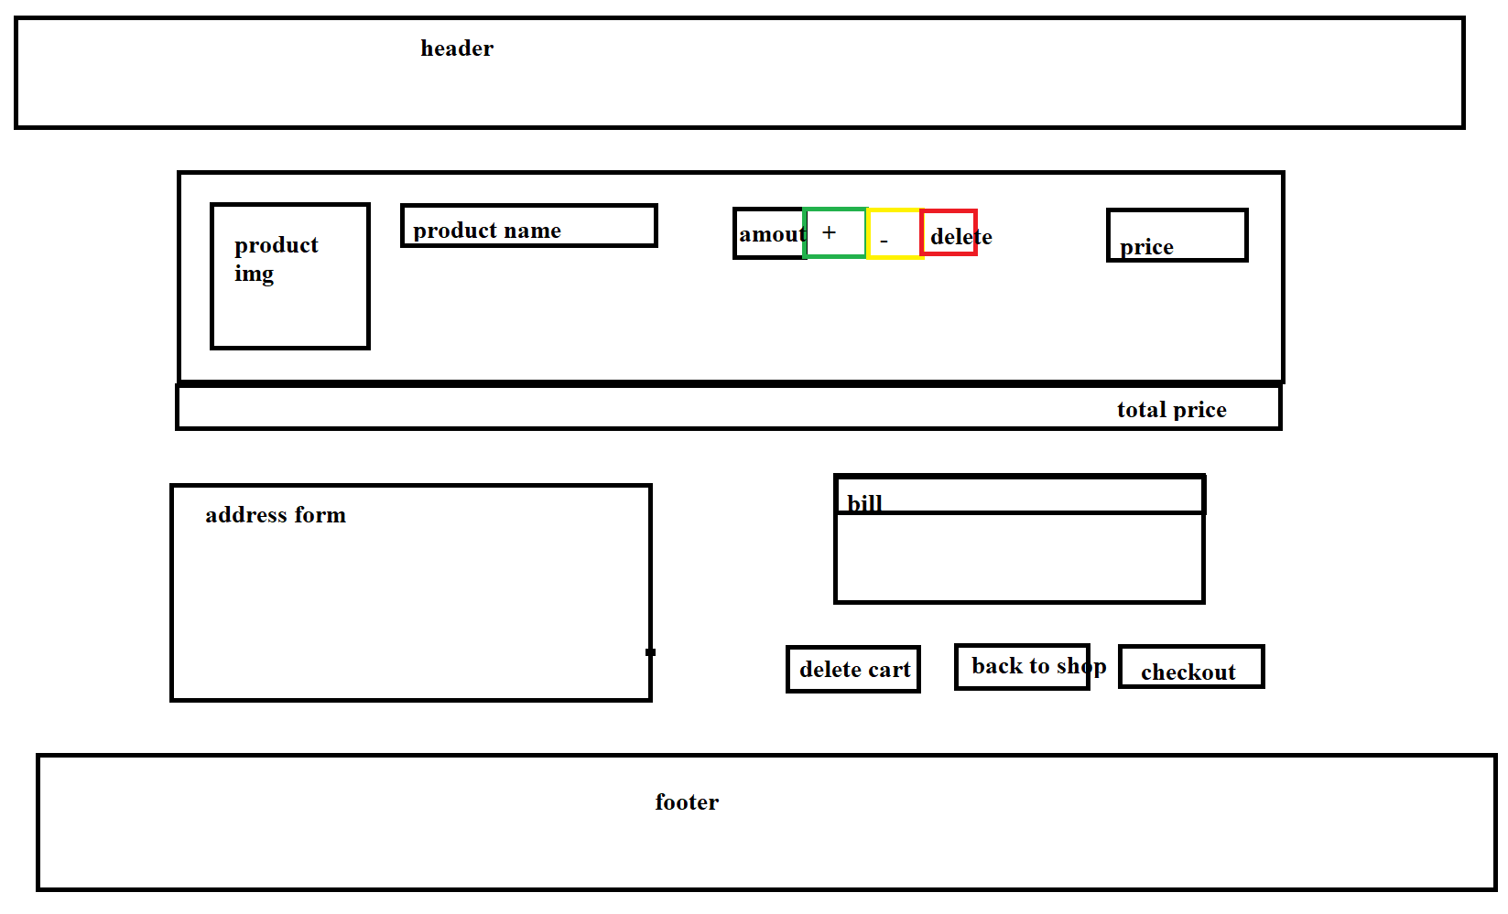

*Figure 2.11.1 Shopping Cart screen*

* Function Details: Show the user the list of products in the cart.
* Use-Case Diagram:
* Use-Case Description:

|  |  |
| --- | --- |
| Use Case ID | UC-10 |
| Use Case Name | View cart |
| Actor | User |
| Description |  |
| Precondition |  |
| Post-Condition |  |
| Main Flow |  |
| Alternative flows |  |

### 2.12. Delete Product in Cart

* Function trigger: When the user does not want to pay for the product, press the Delete button to remove it from the cart.
* Function description:
  + Actors/roles: Guest, Customer.
  + Purpose: User wants to remove product from cart.
  + Data processing: Delete products stored in cookies.
* Screen layout: mockup prototype of the screen, sample below is for Manage Products screen

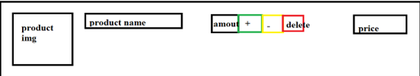

*Figure 2.12.1 Delete Product*

* Function Details: Remove product from cart.
* Use-Case Diagram:
* Use-Case Description:

|  |  |
| --- | --- |
| Use Case ID | UC-11 |
| Use Case Name | Delete Product in Cart |
| Actor | User |
| Description |  |
| Precondition |  |
| Post-Condition |  |
| Main Flow |  |
| Alternative flows |  |

### 2.13. CheckOut

* Function trigger: User wants to order product.
* Function description:
  + Actors/roles: Customer.
  + Purpose: Create product orders.
* Screen layout:



*Figure 2.13.1 CheckOut*

* Function Details: Create product orders.
* Use-Case Diagram:
* Use-Case Description:

|  |  |
| --- | --- |
| Use Case ID | UC-12 |
| Use Case Name | Check Out |
| Actor | User |
| Description |  |
| Precondition |  |
| Post-Condition |  |
| Main Flow |  |
| Alternative flows |  |

### 2.14. Place Order

* Function trigger: User wants to pay for the order.
* Function description:
  + Actors/roles: Customer.
  + Purpose: Payment processing for orders.
* Screen layout:

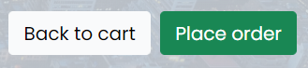

*Figure 2.14.1 Place Order*

* Function Details: Payment order.
* Use-Case Diagram:
* Use-Case Description:

|  |  |
| --- | --- |
| Use Case ID | UC-13 |
| Use Case Name | Place Order |
| Actor | User |
| Description |  |
| Precondition |  |
| Post-Condition |  |
| Main Flow |  |
| Alternative flows |  |

### 2.15. View order

* Function trigger: User wants to view his order by clicking View My Orders on Profile page.
* Function description:
  + Aactors/roles: Customer.
  + Purpose: Double check the orders.
* Screen layout:

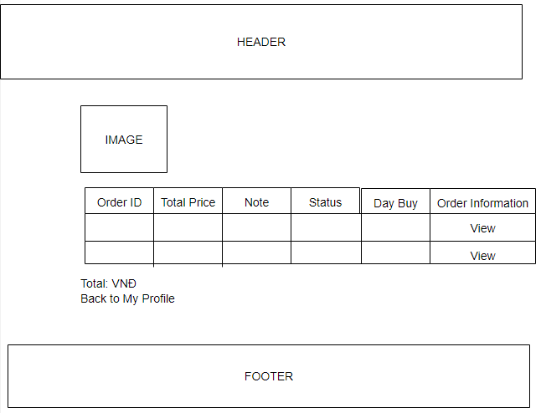

*Figure 2.15.1 View Order screen*

* Function Details: Displays a list of orders that have been placed.
* Use-Case Diagram:
* Use-Case Description:

|  |  |
| --- | --- |
| Use Case ID | UC-14 |
| Use Case Name | View order |
| Actor | User |
| Description |  |
| Precondition |  |
| Post-Condition |  |
| Main Flow |  |
| Alternative flows |  |

### 2.16. View Order Detail

* Function trigger: Users log-in to the website, access My Orders page and click View button.
* Function description:
  + Actors/roles: Customer.
  + Purpose: See the order detailed information.
* Screen layout:

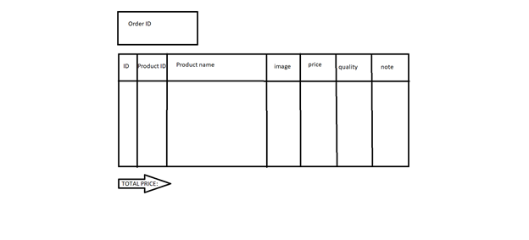

*Figure 2.16.1 View Order Detail screen*

* Function Details: Display details of products included in the order.
* Use-Case Diagram:
* Use-Case Description:

|  |  |
| --- | --- |
| Use Case ID | UC-15 |
| Use Case Name | View order detail |
| Actor | User |
| Description |  |
| Precondition |  |
| Post-Condition |  |
| Main Flow |  |
| Alternative flows |  |

### 2.17. Feedback

* Function trigger: When the user receives the goods, click on My order and then click on Feedback and evaluate.
* Function description:
  + Actors/roles: Customer.
  + Purpose: Customer writes and send a Feedback about a Product.
* Screen layout:

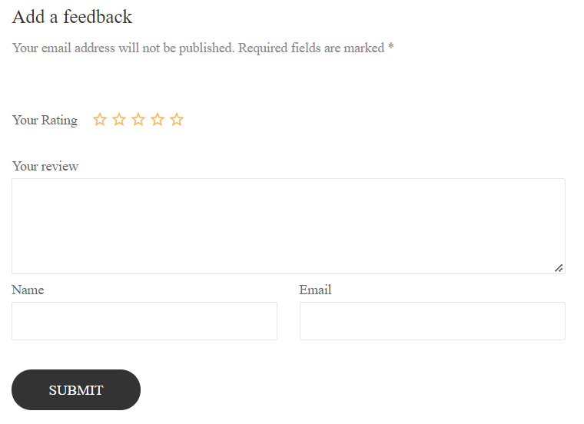

*Figure 2.17.1 Feedback screen*

* Function Details: Allows users to submit product feedback reviews after receiving the item.
* Use-Case Diagram:
* Use-Case Description:

|  |  |
| --- | --- |
| Use Case ID | UC-16 |
| Use Case Name | Feedback |
| Actor | User |
| Description |  |
| Precondition |  |
| Post-Condition |  |
| Main Flow |  |
| Alternative flows |  |

### 2.18. View Feedback (For user)

* Function trigger: Customers click on the product they want to see, scroll down to see the feedback of other users.
* Function description:
  + Actors/roles: Guest, Customer.
  + Purpose: See all comments by other users.
* Screen layout:
* Function Details: Show users all comments, star reviews from other customers.
* Use-Case Description:

|  |  |
| --- | --- |
| Use Case ID | UC-17 |
| Use Case Name | View Feedback |
| Actor | User |
| Description |  |
| Precondition |  |
| Post-Condition |  |
| Main Flow |  |
| Alternative flows |  |

### 2.19. Blogs List

* Function trigger: User click Blogs on menu bar in Homepage.
* Function description:
  + Aactors/roles: Guest, Customer.
  + Purpose: Customer views the list of all Blogs.
  + Interface: There are pictures and intro.
* Screen layout:

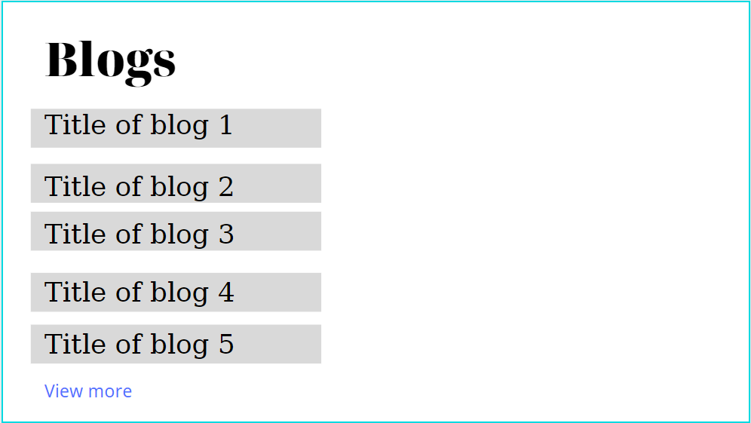

*Figure 2.19.1 Blogs screen*

* Function Details: Display list of all Blogs.
* Use-Case Description:

|  |  |
| --- | --- |
| Use Case ID | UC-18 |
| Use Case Name | Blog list |
| Actor | User |
| Description | This use case allows the user to see a list of Blogs posted by the seller |
| Precondition | None |
| Post-Condition | None |
| Main Flow | 1. Users access the store on the Website according to the link  2. Click the Blog link on the navigation bar  3. The use case ends |
| Alternative flows | None |

### 2.20. Blogs Detail

* Function trigger: User click Blogs on menu bar in Homepage, then click on Blogs they want to see detail.
* Function description:
  + Aactors/roles: Guest, Customer.
  + Purpose: Customer views the Detail information of 1 Blog.
  + Interface: There are pictures, title of Blogs, intro, author.
* Screen layout:

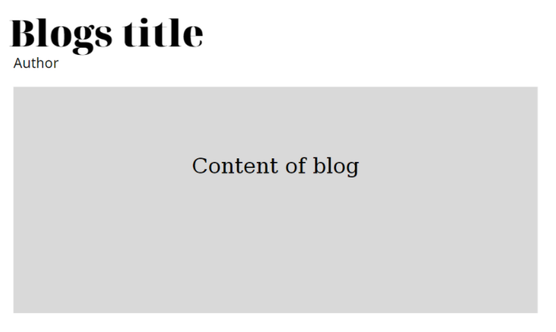

*Figure 2.20.1 Blogs Detail screen*

* Function Details: Display detail of 1 Blogs.
* Use-Case Description:

|  |  |
| --- | --- |
| Use Case ID | UC-19 |
| Use Case Name | Blog Detail |
| Actor | User |
| Description | This use case allows the user to view detailed information of the Blog including the Blog's author name, the date of writing, the Blog's content |
| Precondition | None |
| Post-Condition | None |
| Main Flow | 1. Users access the store on the Website according to the link  2. Click the Blog link on the navigation bar  3. Click on Blog's name, image or "Read More" redirect  4. The use case ends |
| Alternative flows | None |

### 2.21. Notification

* Function trigger: User logs in to the site, clicks the bell and clicks the "View All" link, or looks at the Notifications section of the Profile.
* Function description:
  + Aactors/roles: Customer, Seller, Admin.
  + Purpose: User views the list of all Notifications.
* Screen layout:

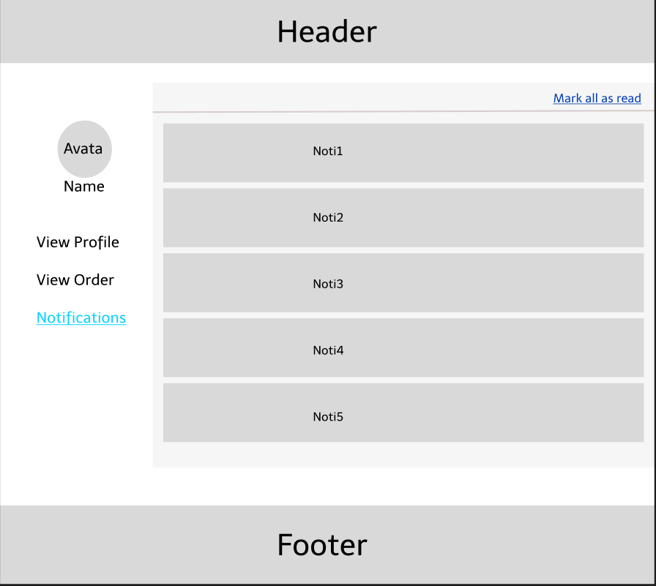

*Figure 2.21.1 View Notifications screen*

* Function Details: Display list of all Notifications.
* Use-Case Description:

|  |  |
| --- | --- |
| Use Case ID | UC-20 |
| Use Case Name | Notification |
| Actor | User |
| Description |  |
| Precondition |  |
| Post-Condition |  |
| Main Flow |  |
| Alternative flows |  |

### 2.22. Mask all as read

* Function trigger: User logs-in the website, clicks on the text “Mark all as read”.
* Function description:
  + Aactors/roles: Customer, Seller, Admin.
  + Purpose: Let users mark all notifications as read.
* Screen layout:
* Function Details: Display list of all Blogs.

### 2.23. Introduciton

* Function trigger: User click About on menu bar in Homepage screen.
* Function description:
  + Aactors/roles: Guest, Customer.
  + Purpose: Customer views the list of all Blogs.
  + Interface: There are pictures, intro, Google Map.
* Screen layout:

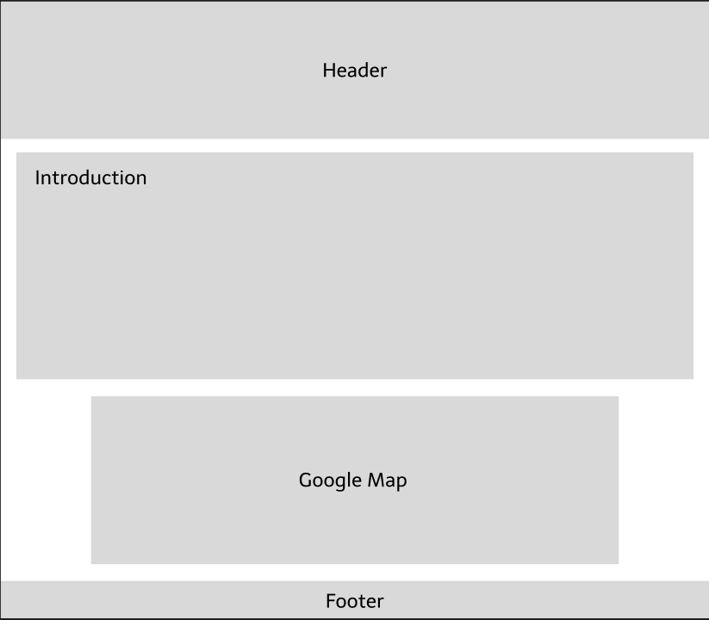

*Figure 2.23.1 Blogs screen*

* Function Details: Display list of all Blogs.
* Use-Case Description:

|  |  |
| --- | --- |
| Use Case ID | UC-21 |
| Use Case Name | Introduction |
| Actor | User |
| Description | This use case allows the user to view the general information of the online store, its history, and the store's address using Google Map. |
| Precondition | None |
| Post-Condition | None |
| Main Flow | 1. Users access the store on the Website according to the link  2. Click the About US link on the navigation bar or under Footer |
| Alternative flows | None |

### 2.24. Recruitment

* Function trigger: The user clicks Recruitment on the menu bar in the About screen, then clicks on the job posting link to switch to viewing the recruitment information.
* Function description:
  + Aactors/roles: Guest, Customer.
  + Purpose: Users can view job postings.
  + Interface: There are pictures, job postings.
* Screen layout:

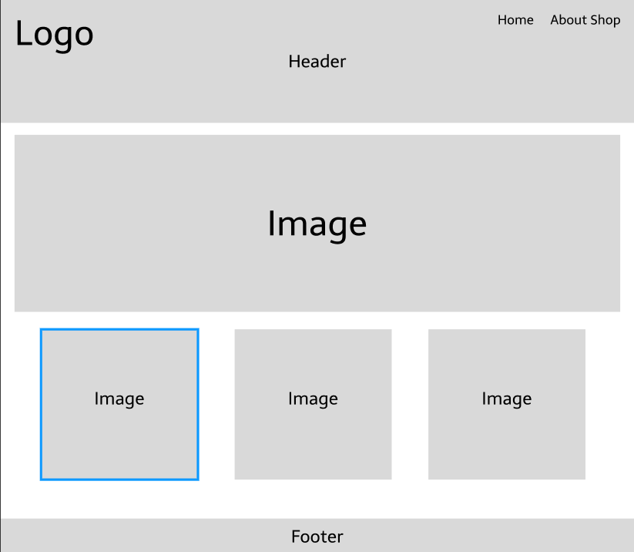

*Figure 2.24.1 Main Recruitment screen*

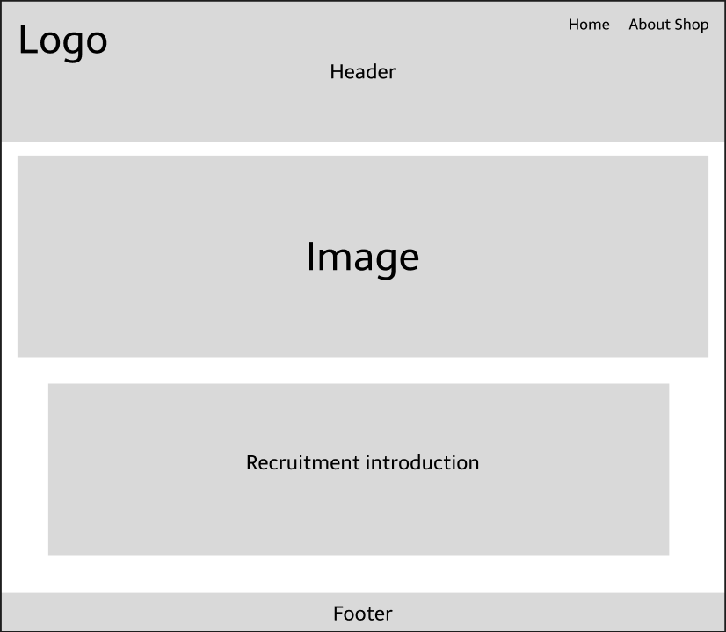

*Figure 2.24.2 Recruitment Detail screen*

* Function Details: Show details of recruitment information.

### 2.25. Admin Dashboard

* Function trigger: Admin login successfully then access the management page.
* Function description:
  + Actors/roles: Admin
  + Purpose: Allow admin can view detailed statistics, revenue, website visitors.
* Screen layout:

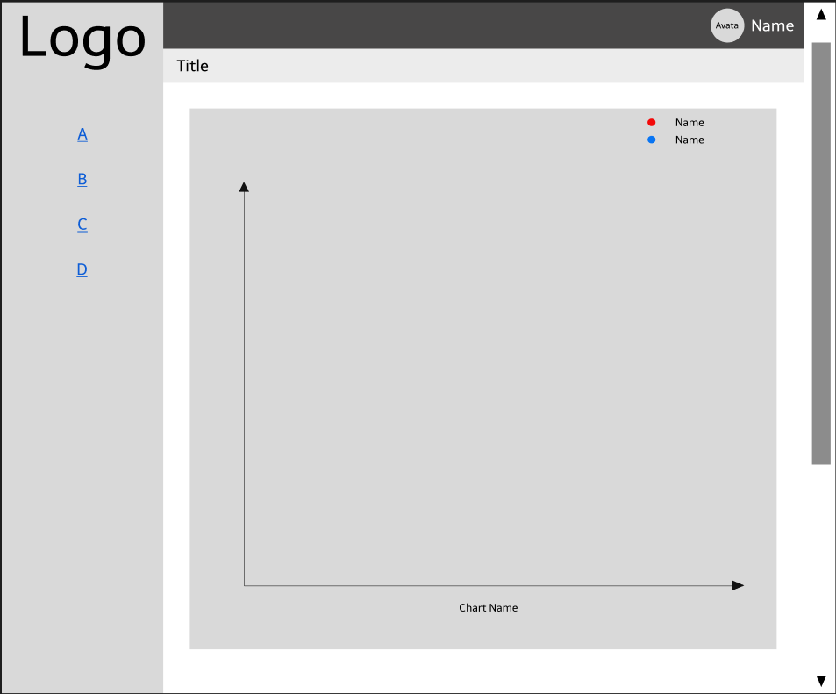

*Figure 2.25.1 Admin Dashboard screen*

* Function Details: View detailed statistics, website visitors, revenue.

### 2.26. List of Account (Admin)

* Function trigger: Admin login successfully then access the View Account page.
* Function description:
  + Actors/roles: Admin
  + Purpose: Admin successfully login to the management page and click on the View Account button.
* Screen layout:

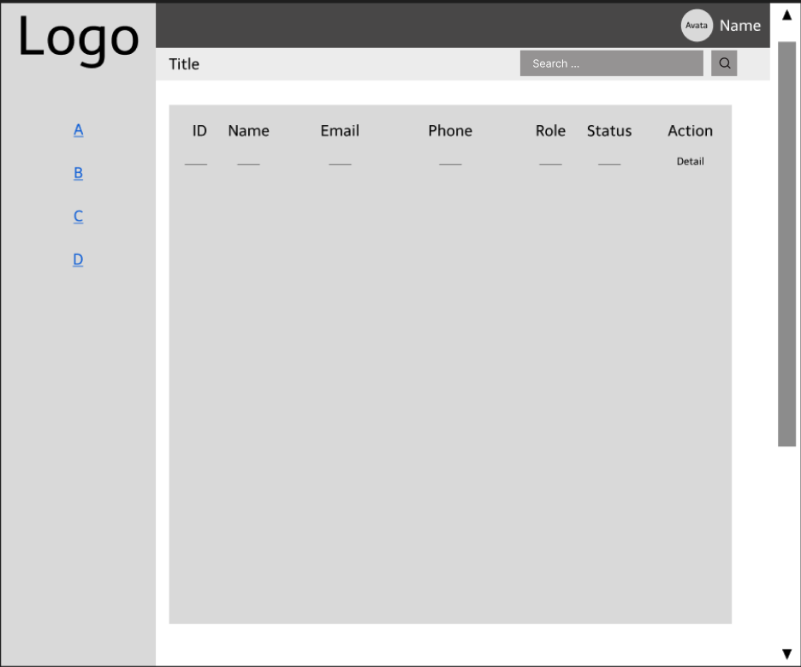

*Figure 2.26.1 List Account screen*

* Function Details: View the list of accounts registered on the system.

### 2.27. Account Information (Admin)

* Function trigger: When the admin is on the View Account page, click on the Individual icon to view the user's details..
* Function description:
  + Actors/roles: Admin.
  + Purpose: Allows administrators to view detailed account information of customers, seller, other admins or personal information.
* Screen layout:

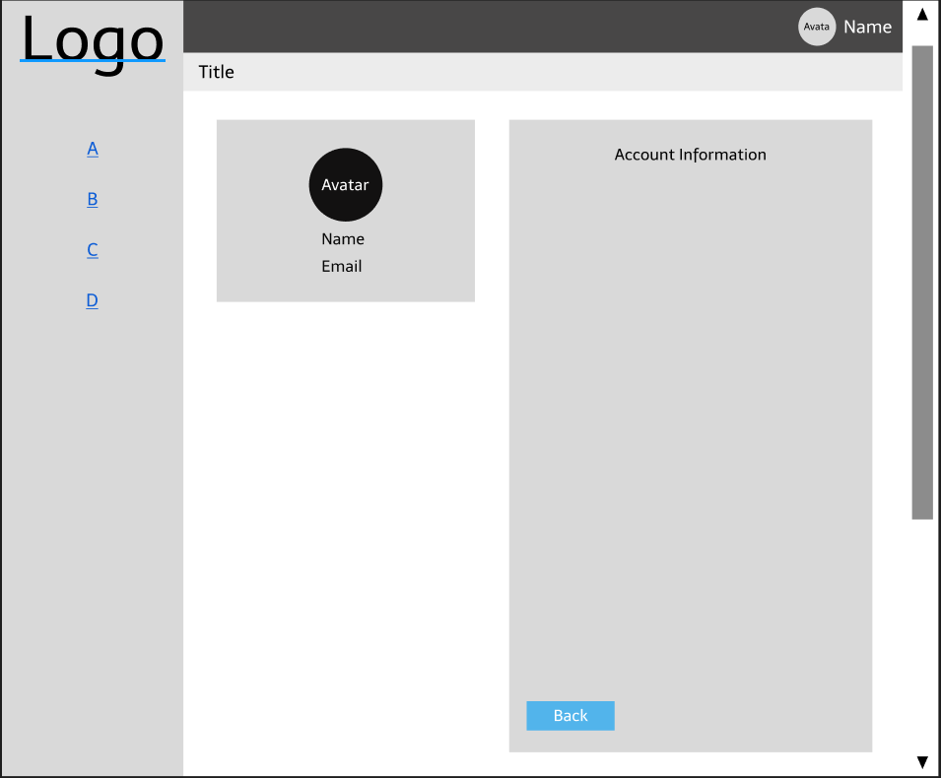

*Figure 2.27.1 Account Information screen*

* Function Details: View detailed account information of customers, sellers, admin.

### 2.28. Search (Admin)

* Function trigger: Admin enter the account name in the Search bar and click the magnifying glass button on the upper right hand side of the screen.
* Function description:
  + Actors/roles: Admin.
  + Purpose: Allow admin to search user's account name when there are too many accounts stored in the system.
* Screen layout:



*Figure 2.28.1 User's Account Search by Name*

* Function Details: User Account Search.

### 2.29. Seller Dashboard (Seller)

* Function trigger: When Seller clicks on My Dashboard on the homepage.
* Function description:
  + Actors/roles: Seller.
  + Purpose: Allow merchants to log in to Seller Dashboard to view store statistics.
* Screen layout:

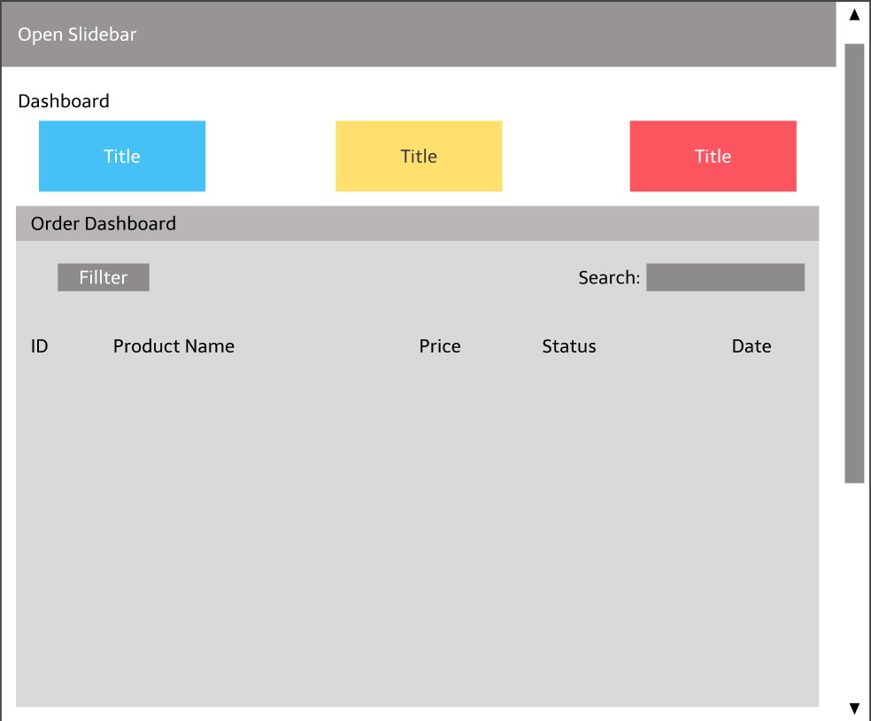

*Figure 2.29.1 Seller Dashboard screen*

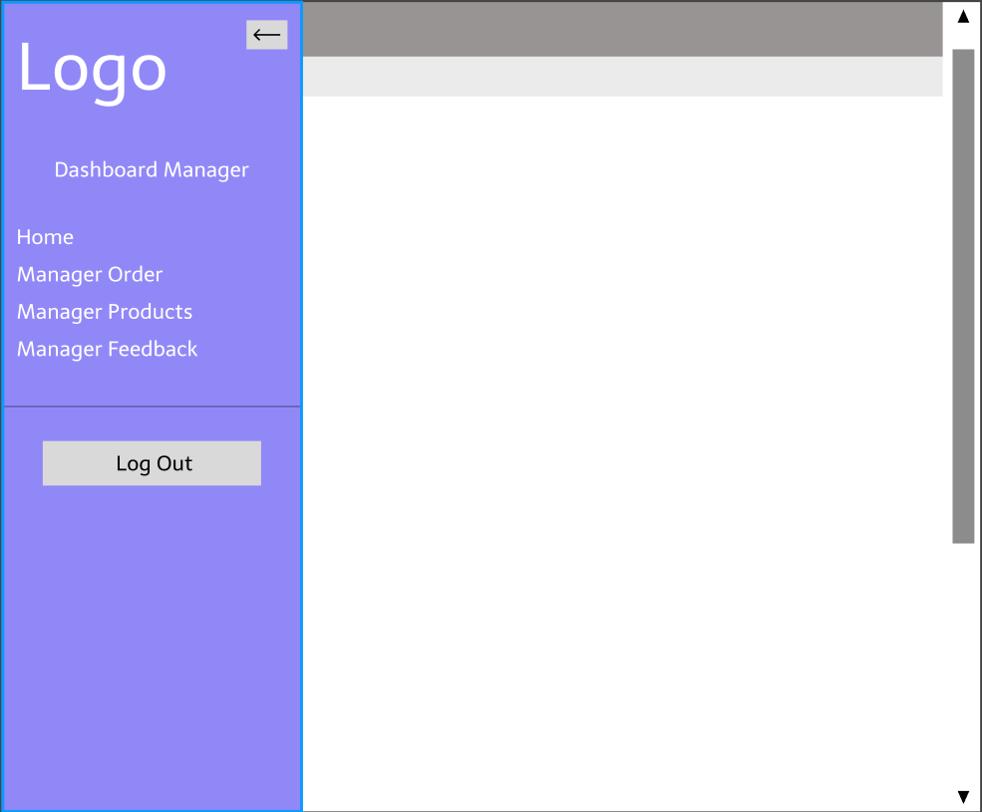

*Figure 2.29.2 Open Slidebar on Seller Dashboard*

* Function Details: Displaying the Main Dashboard panel, Seller clicks the Open Sidebar button to open tasks such as Manage Orders, Manage Products, View User Feedback or Log Out.

### 2.30. Manager Order (Seller)

* Function trigger: When the seller clicks Manage Orders in the Slidebar.
* Function description:
  + Actors/roles: Seller.
  + Purpose: Allows the seller to view the list of orders.
* Screen layout:

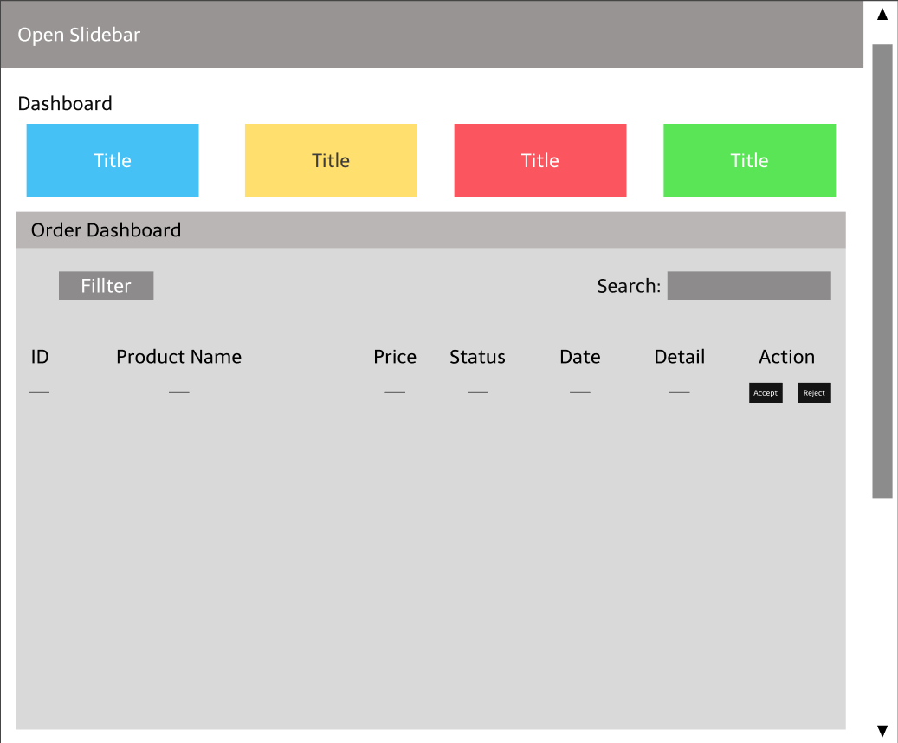

*Figure 2.30.1 Order Dashboard screen*

* Function Details: View store revenue, order list, order status update, search.

### 2.31. Manager Product (Seller)

* Function trigger: When the seller clicks Manage Product in the Slidebar.
* Function description:
  + Actors/roles: Seller.
  + Purpose: Allows the seller to view the list of products.
* Screen layout:

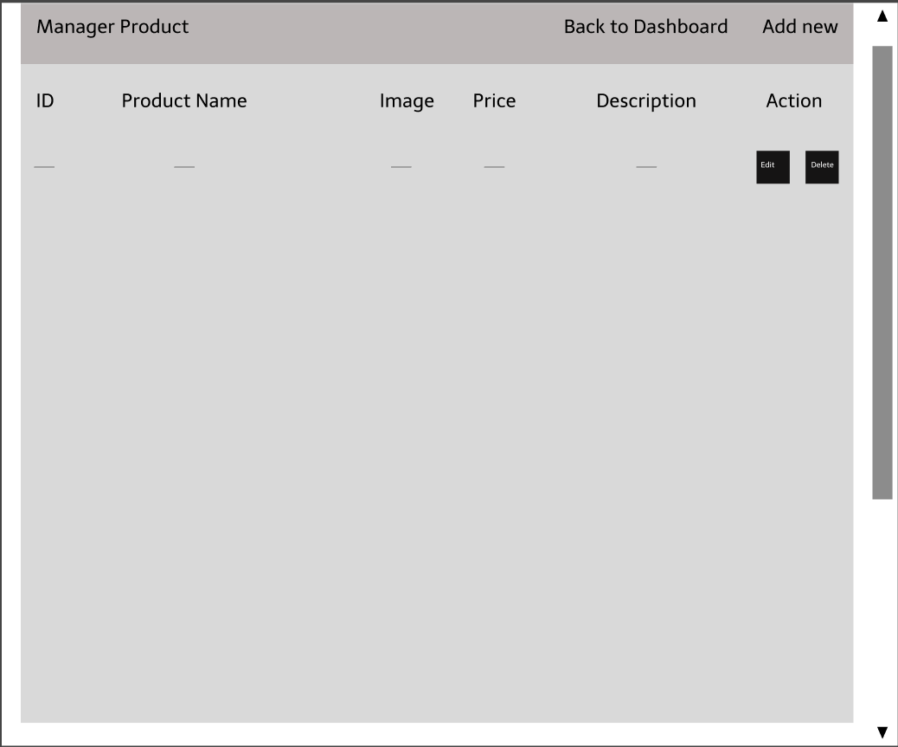

*Figure 2.31.1 Manager Products screen*

* Function Details: Show a list of products currently in the store.

### 2.32. Add new Product (Seller)

* Function trigger: When the seller clicks the Add New button on the top right side of the screen.
* Function description:
  + Actors/roles: Seller.
  + Purpose: Allow sellers to post new products.
* Screen layout:

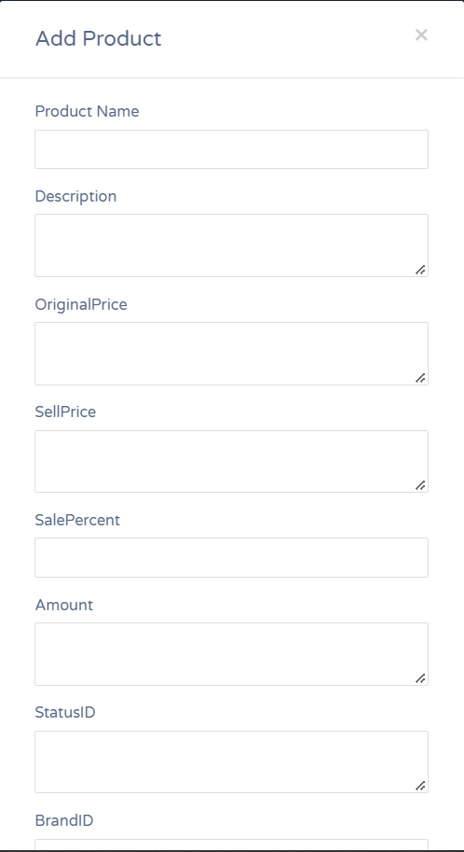

*Figure 2.32.1 Add new Product screen*

* Function Details: Add a new product to the list of existing products.

### 2.33. Edit Product

* Function trigger: When the seller clicks the Edit button in the Actions section.
* Function description:
  + Actors/roles: Seller.
  + Purpose: Allows sellers to edit product information.
* Screen layout:

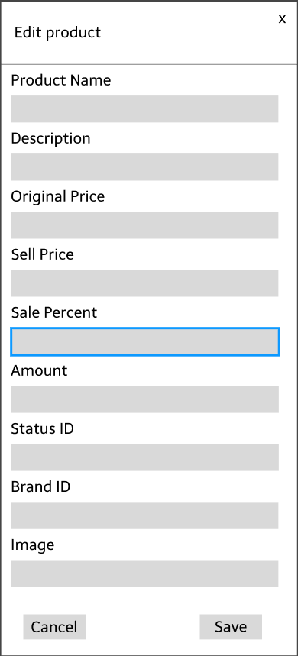

*Figure 2.33.1 Edit Product screen*

* Function Details: Update product information.

### 2.34. Delete product

* Function trigger: When the seller clicks the Delete button in the Actions section.
* Function description:
  + Actors/roles: Seller.
  + Purpose: Allow users to remove products from the list.
  + Data processing: The system sends a message asking to confirm Delete the product.
* Screen layout:



*Figure 2.34.1 Delete Product*

* Function Details: Delete product.

### 2.35. Manage Feedback List (Seller)

* Function trigger: When the seller clicks Manage Feedback in the Slidebar.
* Function description:
  + Actors/roles: Seller.
  + Purpose: Show seller all star reviews and user feedback on the product.
* Screen layout:

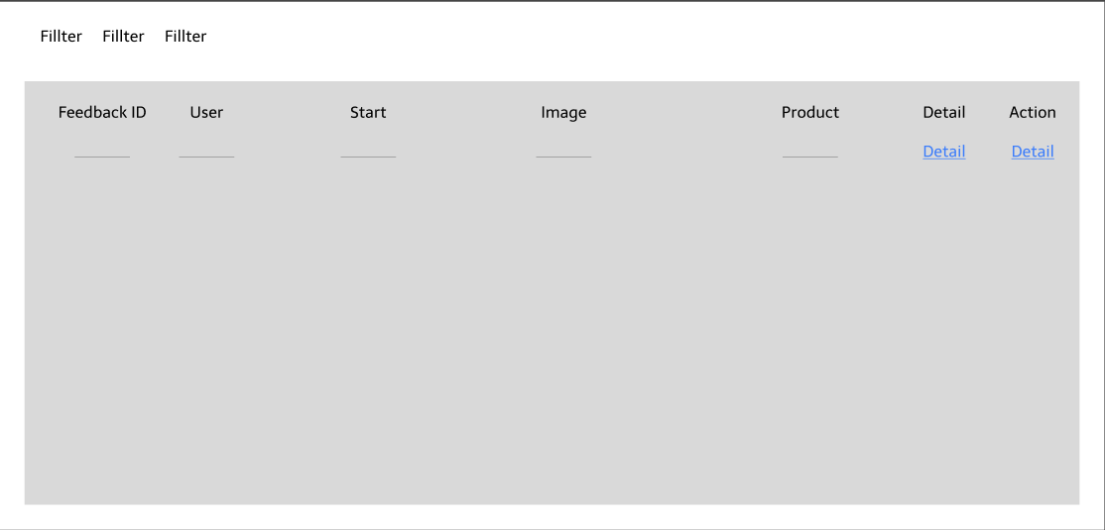

*Figure 2.35.1 List Feedback screen*

* Function Details: Displays all user feedback reviews about the product, can be sorted by Star rating, by time, alphabetically by username, ..

### 2.36. Feedback Detail

* Function trigger: When the seller clicks button Detail in the Action sesions.
* Function description:
  + Actors/roles: Seller.
  + Purpose: Display details of user feedback for products so seller can view and respond..
* Screen layout:

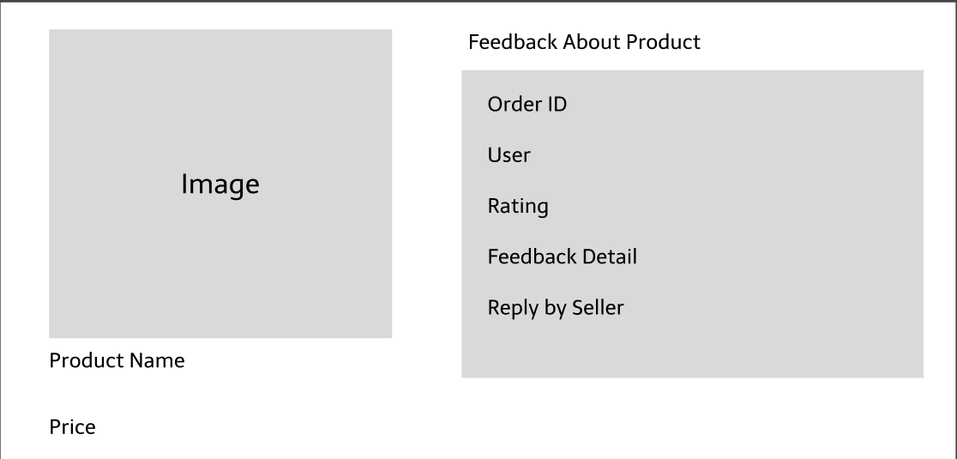

*Figure 2.36.1 Feedbakc Detail screen*

* Function Details: Show response details when seller clicks Detail button.

### 2.37. Reply Feedback

* Function trigger: When the user clicks the Reply button in the Actions section, the system directs the user to the Feedback reply page.
* Function description:
  + Actors/roles: Seller.
  + Purpose: Let merchants see and respond to user feedback.
  + Data processing: The system records the seller’s answer and updates the data and then returns the message to the user.
* Screen layout:

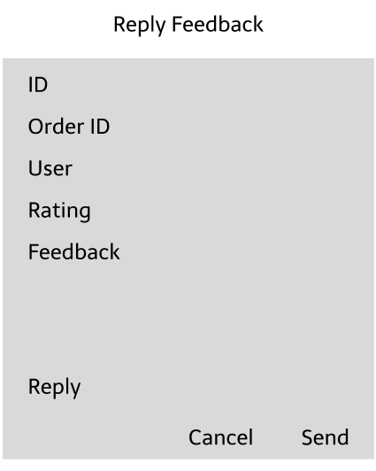

*Figure 2.37.1 Feedbakc Detail screen*

* Function Details: Send a reply message or update a reply message.